**Voxelwise statistic, two independent groups**

**CONTENTS**

**1) Create a group-assignment (Excel-file)**

**2) Perform the voxelwise-T-test (independent group)**

**3) Examine Results**

**3.1) EXPORT RESULTS-TABLE AS EXCELFILE**

**3.2) DISPLAY RESULT TABLE IN COMMAND WINDOW**

**3.3) EXPORT RESULTS-TABLE AS TXT-FILE**

**3.4) SAVE THREHOLDED IMAGE AS NIFTI-FILE**

**3.5) EXTRACT PEAK DATA**

**3.6) CREATE SUMMARY OF CURRENT CONTRAST**

**3.7) Change to Cluster-based approach**

**4) Check the other contrast**

**Scenario**

-**Artificial data** for 14 animals were created, with spherical differences centered in the a) **left Primary somatosensory area mouth layer 4** and b) the **right CaudoPutamen**

Here we have two groups with 6 and 8 animals in each group. The artificially created files are stored as “vimg.nii”-image in the respective animal-folders. Note that the animal-folders are empty, except of the “vimg.nii”-image. This image is in register to the Allen mouse brain atlas ( i..e already in standard space).

**Prerequisites**

-a project with project file was created …when doing this analysis with your own data, the image that should be analyzed using voxelwise statistic must be in the standard/template space (here : Allen mouse brain space). For instance when analyzing the gray matter image(“c1t2.nii”), the image has to be transformed to standard space to make voxelwise statistic feasable.

-Templates: here ‚the **mouse_Allen2017HikishimaLR**‘-template is already imported in the study’s templates-folder

- start ANT-gui and set current working directory to project-folder path

-load project (m-file, here proj.m)

**5) CREATE BIG-SUMMARY**

**6) Define new Contrast**

**7) Work from Command line**

**7.1) run voxelwise statistic from command line**

**7.2) Create full report**

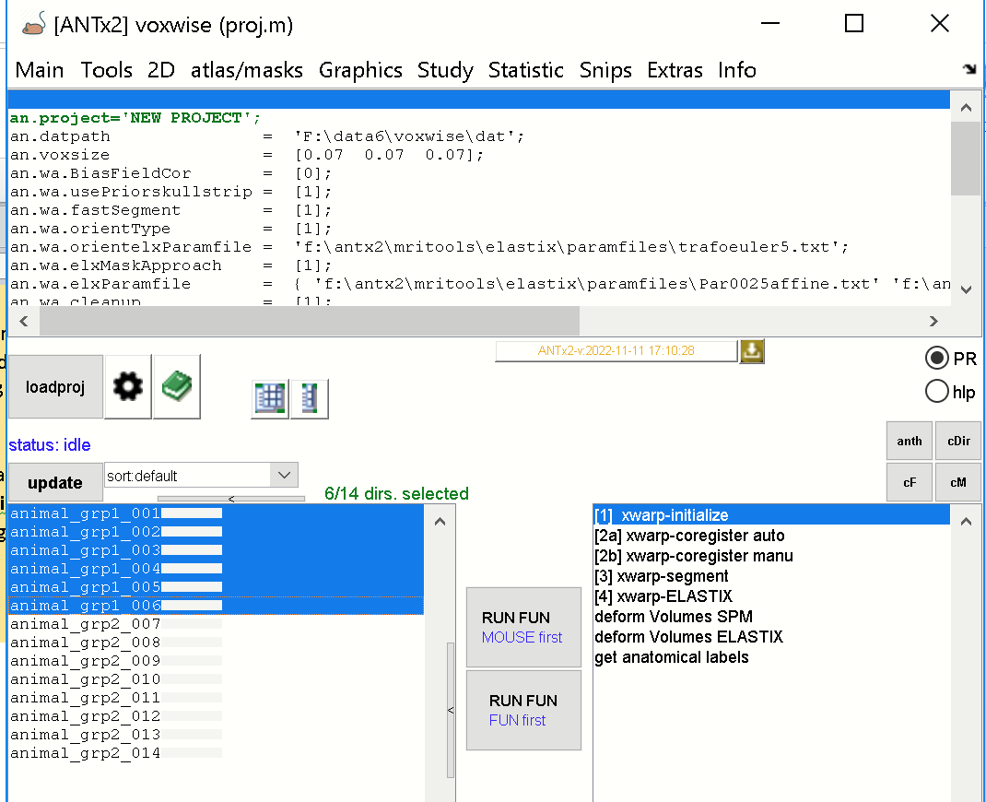

The Figure shows the list of 14 animals (left listbox). Animals of group-1 is selected (just for displaying purpose). Note that for this animals artificial data were created.

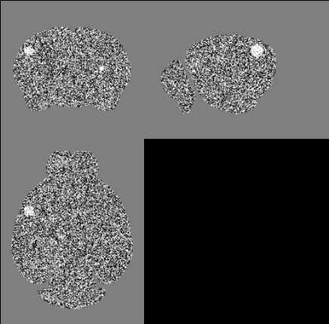

The figure shows the simulated image ‘vimg.nii’ (image is in standard-space) of one animal from the 2nd group with increased intensities centered at a) the left Primary somatosensory area mouth layer 4 and b) the right CaudoPutamen.

**1) Create a group-assignment (Excel-file)**

We now need a group-assignment file (Excel-file) with definitions of animals and group-assignment.

For this select: **Statistic/create group assignment file** from the **ANTx-MENU**.

This will open the repective parameter file. We keep the default parameter and hit [**RUN**].

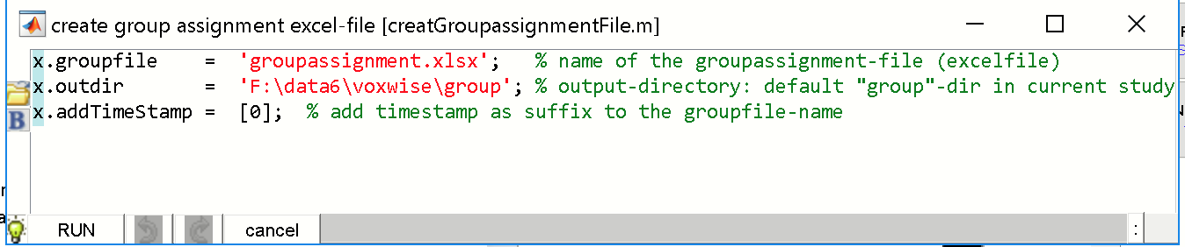

To this end, the Excelfile **“groupassignment.xlsx”** is created, located in the “**group**”-folder in the current study directory (“F:\data6\voxwise\group”).

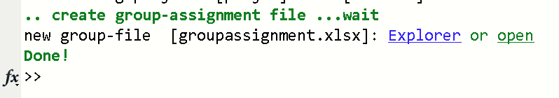

You can select the **‘open’-**hyperlink in the command-window to open the Excel-file. The 1st sheet of the excelfile looks as follows:

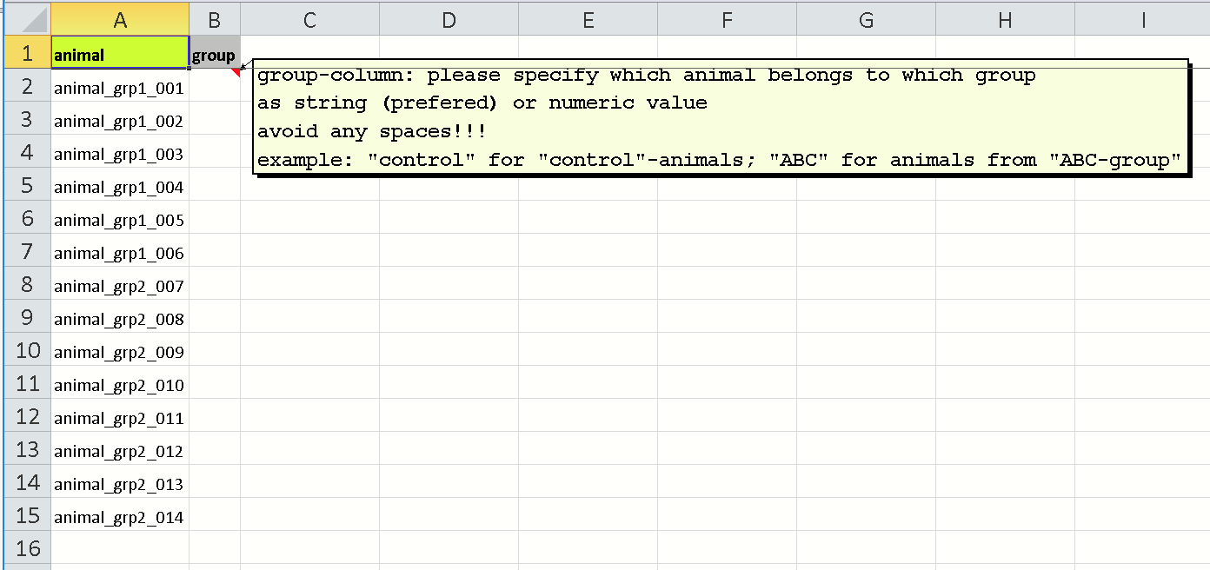

The first column contains the animal-IDs of all animals of the current study. The 2nd column has to be filled with the respective group-assignment. Here the 1st 6 animals belong to the control-group, thus the ‘**control**’-string is inserted for those animals, while the other animals belong to the “**VIMG**”-group, thus the “**VIMG**”-string is inserted in the 2nd column (see Fig. below). Note that the string-names are arbitrary. Try to avoid special characters! Save this modifications (here the same filename, **“groupassignment.xlsx**”, is used).

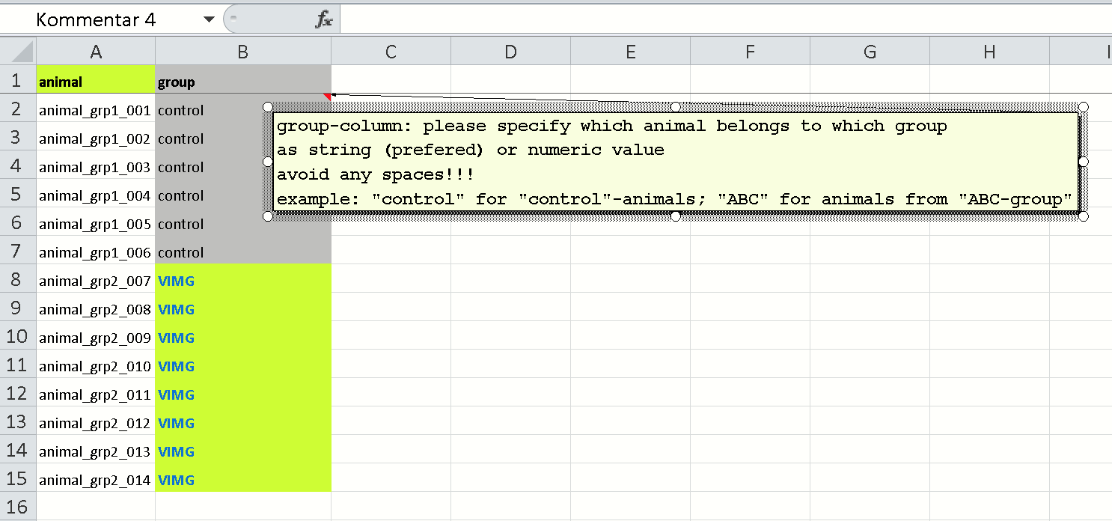

**2) Perform the voxelwise-T-test (independent group)**

We now want to run the independent voxelwise t-test comparing the two groups for the “vimg.nii”-image.

For this select: **Statistic/SPM-statistic** from the **ANTx -MENU**. This will call the main GUI (from the function xstat.m):

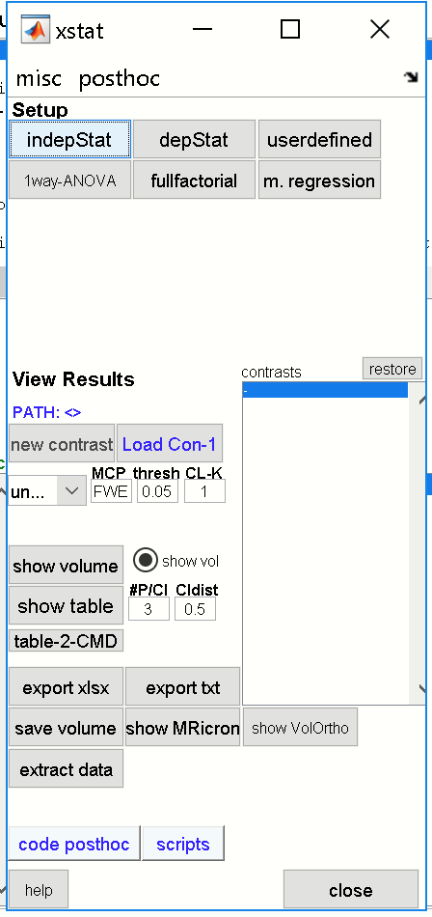

Next, select the [**indepStat**]-button to open the parameter-GUI for the voxelwise independent t-test (TWO-SAMPLE-TTEST). The default parameter-GUI looks as follows:

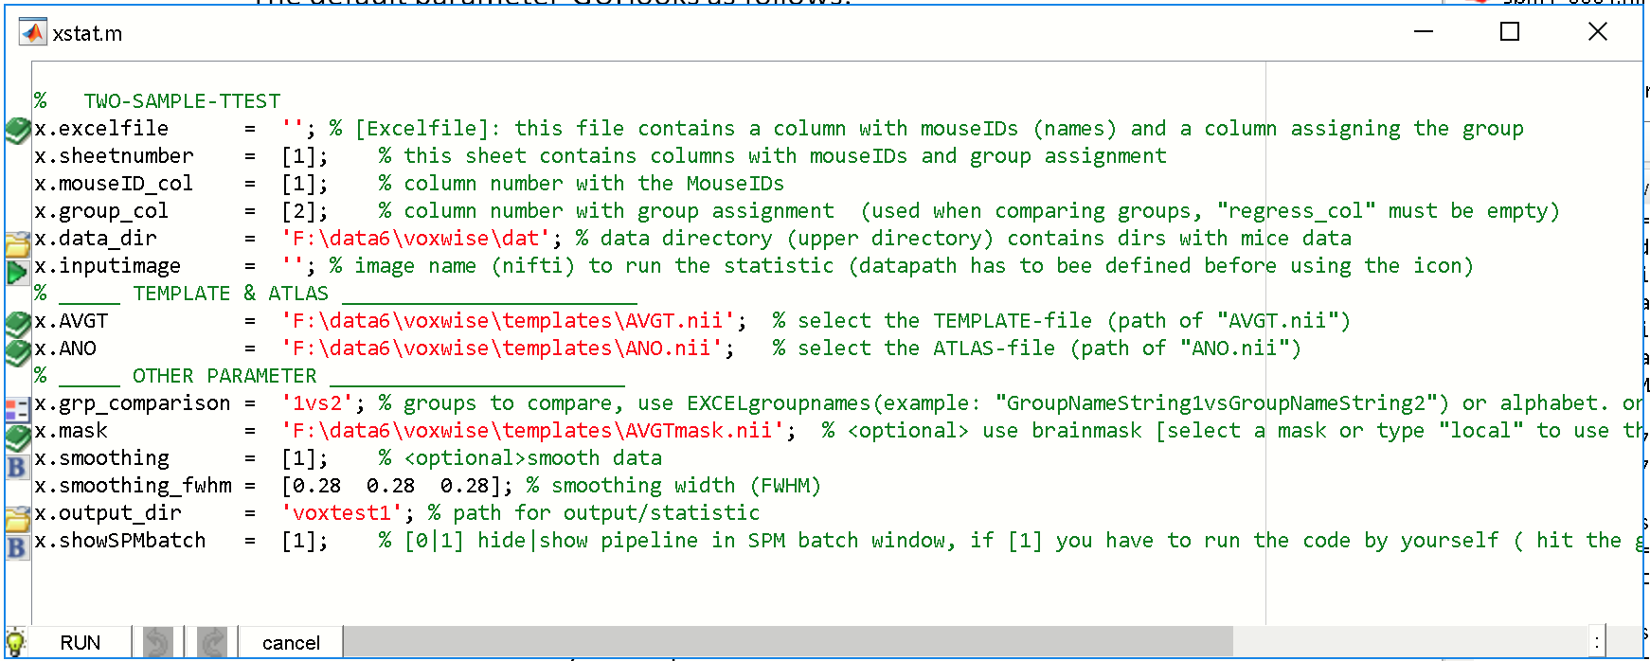

We now need to modify (or check) some parameters:

- “**x.excelfile”:** click the left icon and select the group-assignment-file (“groupassignment.xlsx”) located in the group-folder.

- “**x. data_dir**”: click the left icon and select the study’s dat-folder (This folder contain the animals-data and the image that should be statistically tested).

- “**x. inputimage**”: click the left icon and select the image that should be statistically tested: Specifically in the file-selector GUI select “vimg.nii”, hit [OK].

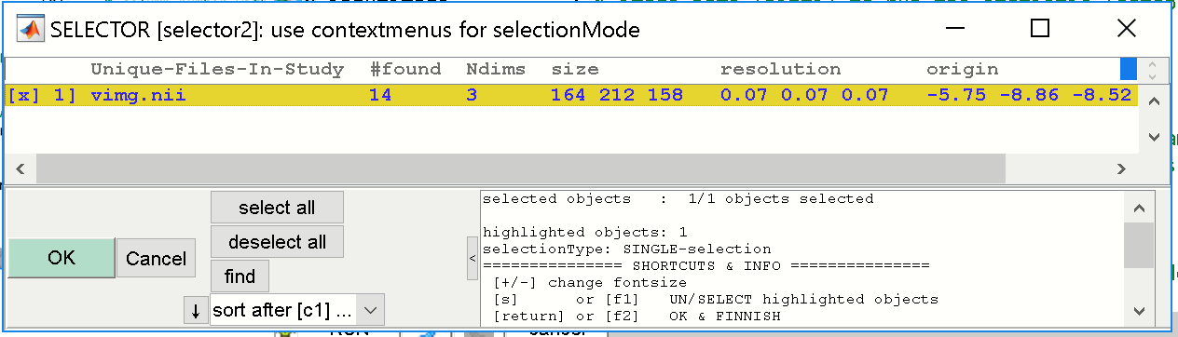

- “**x. AVGT**”: click the left icon and select the AVGT-image (“AVGT.nii”) from the study’s templates-folder.

- “**x. ANO**”: click the left icon and select the ANO-image (“ANO.nii”, i.e. the Atlas) from the study’s templates-folder.

- “**x. mask**”: click the left icon and select the AVGTmask-image (“AVGTmask.nii”) from the study’s templates-folder. Note that the animal-folders only contain the ‘vimg.nii’-image. Thus we have to assign the brain-mask (“AVGTmask.nii”) from the templates-folder.

- “**x.output_dir**”: define the output-folder for the voxelwise statistic, here “**voxtest1**”.

The parameter-Gui should now looks as follows:

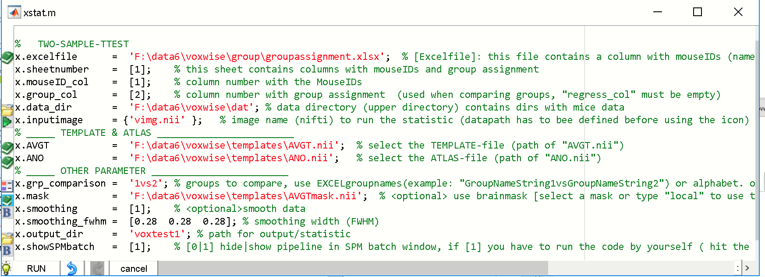

Note that the image ‘vimg.nii’ will be smoothed (“x.smoothing” is set to [1]) by the triple of the voxel-resolution (“x.smoothing_fwhm” is [0.28 0.28 0.28]). Note also, that “x.showSPMbatch” is set to [1]. This parameter will open the SPM-batch-GUI, when hitting the [RUN]-button, allowing for final post-parameter configurations.

Hit [RUN]-button to run the voxelwise statistic. Because the parameter “x.showSPMbatch” was set to [1], the SPM-batch-GUI will pop-up, allowing for specific post-parameter configurations and final checks (see Fig. below).

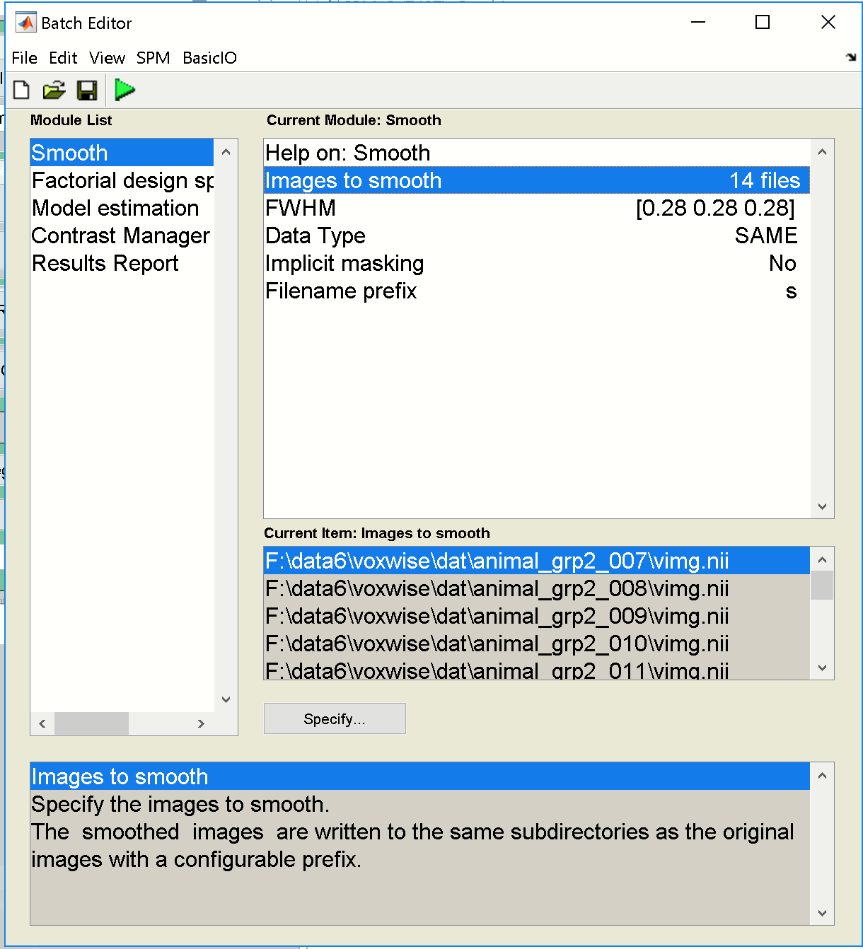

Here, everything seems to be ok and no further changes will be made. Hit [RUN BATCH]-button (green triangle) to execute this batch. The process will take a couple of minutes.

When done, you can obtain the **xstat-batch**, by typing: **“char(anth)”** in Matlab-cmd window or clicking the [anth]-button from the **ANTx-main GUI**:

% % =====================================================

% % #g FUNCTION: [xstat.m]

% % #b info : xstat: voxelwise statistic [SPM-statistic] for normalized data (nifti volumes)

% % =====================================================

z=[];

z.stattype = 'twosamplettest'; % % STATISTICAL TEST

z.excelfile = 'F:\data6\voxwise\group\groupassignment.xlsx'; % % [Excelfile]: this file contains a column with mouseIDs (names) and a column

% % assigning the group

z.sheetnumber = [1]; % % this sheet contains columns with mouseIDs and group assignment

z.mouseID_col = [1]; % % column number with the MouseIDs

z.group_col = [2]; % % column number with group assignment(used when comparing groups, "regress_col"

% % must be empty)

z.data_dir = 'F:\data6\voxwise\dat'; % % data directory (upper directory) contains dirs with mice data

z.inputimage = 'vimg.nii'; % % image name (nifti) to run the statistic (datapath has to bee defined before

% % using the icon)

z.AVGT = 'F:\data6\voxwise\templates\AVGT.nii'; % % select the TEMPLATE-file (path of "AVGT.nii")

z.ANO = 'F:\data6\voxwise\templates\ANO.nii'; % % select the ATLAS-file (path of "ANO.nii")

z.grp_comparison = '1vs2'; % % groups to compare, use EXCELgroupnames(example: "GroupName1vsGroupName2”)

% % or alphabet. order (example: "1vs2"), or

z.mask = 'F:\data6\voxwise\templates\AVGTmask.nii'; % % <optional> use brainmask [select a mask or type "local" to use the AVGTmask.nii

% % from the templates folder]

z.smoothing = [1]; % % <optional>smooth data

z.smoothing_fwhm = [0.28 0.28 0.28]; % % smoothing width (FWHM)

z.output_dir = 'voxtest1'; % % path for output/statistic

z.showSPMbatch = [1]; % % [0|1] hide|show pipeline in SPM batch window, if [1] you have to run the code

% % by yourself ( hit the green driangle), [0] piples runs automatically

xstat(1,z); % % RUN

To rerun the analysis just re-run the code above.

**3) Examine Results**

If the xstat-GUI is closed, type ‘xstat’ in the cmd-window or select: Statistic/SPM-statistic from the **ANTx-MENU**.

Next, hit the [load CON1]-button (below the xstat-“View Results” section) to load the 1st contrast from the analysis.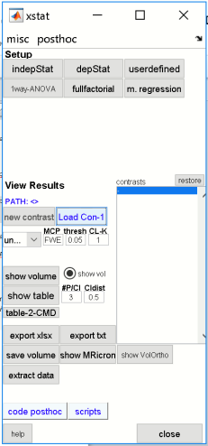

Next, select the path of the voxelwise analysis-folder (**'voxtest1'**) and the respective **SPM.mat**-file (In the below Fig: Select **SPM.mat** from the right listbox, which than appears in the lower listbox, finally hit [Done]).

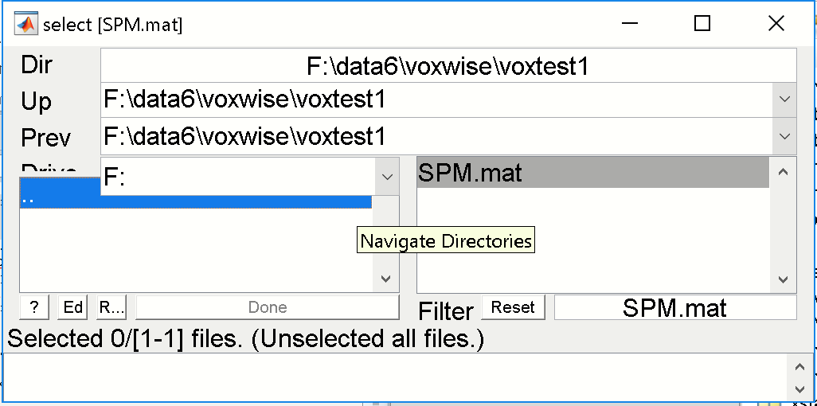

Basically, for the independent t-statistic two contrasts will be calculated by default (‘A>B’ and ‘A<B’). Executing the [load CON1]-button displays the 1st contrast ('VIMG>control').

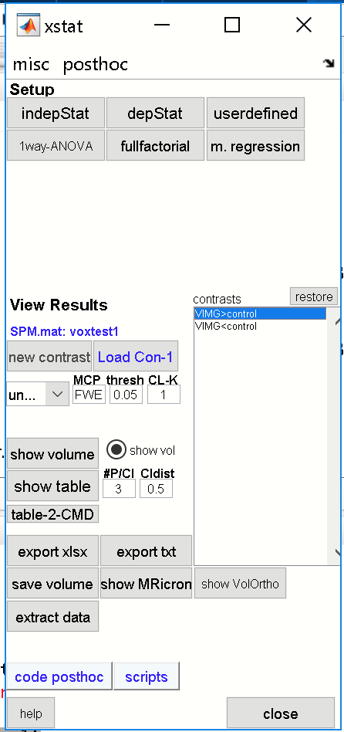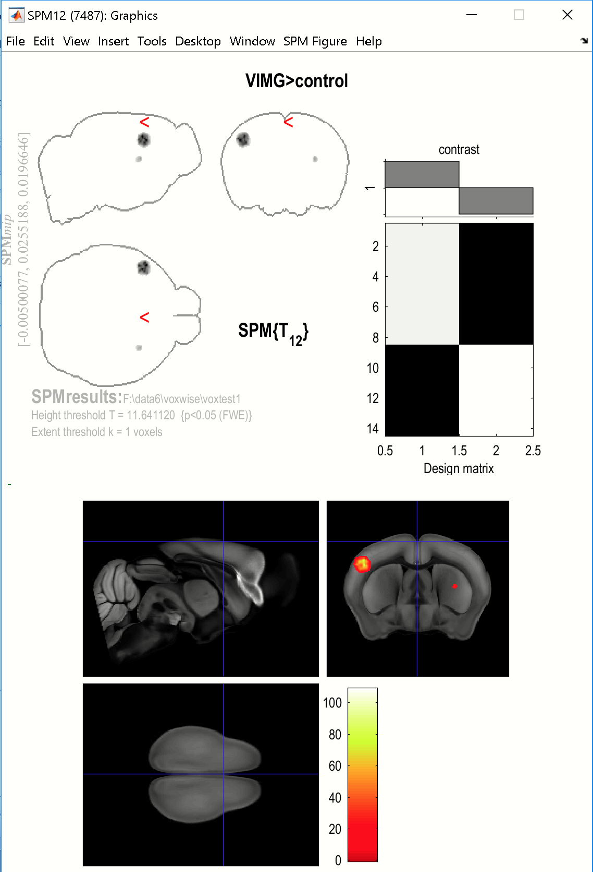

The SPM-graphics window will show the voxelwise results for the 1st contrast **'VIMG>control'** with the parameters, FWE at p=0.05, with min. survival spatial cluster (aka clustersize / sl-k) = 1 voxel. As expected, there are two significant ‘blobs’. To see the associated results table with anatomical annotations, hit the [show table]-button from the xstat-GUI.

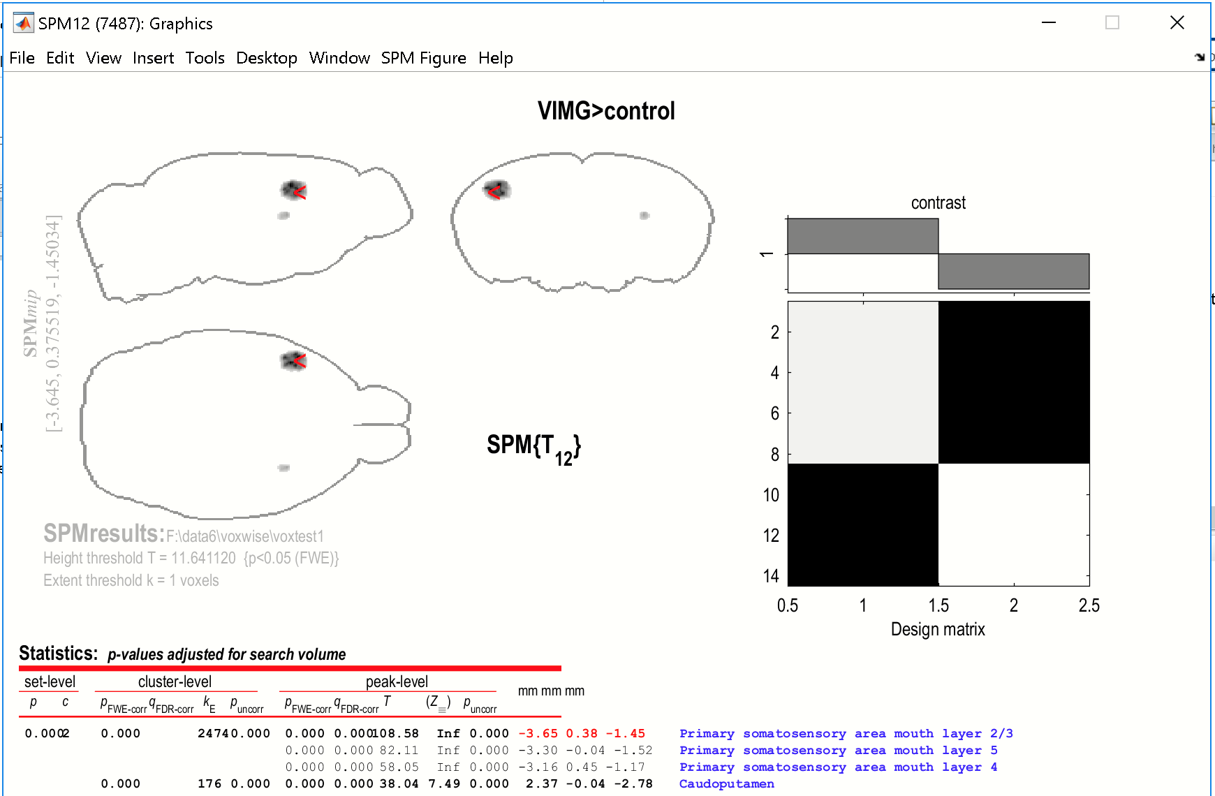

Because, the number of peaks per cluster **(#p/Cl)** is set to 3 and the cluster distance (**CLdist**) is set to 0.5 mm we see three peak clusters within the large left-hemispheric blob. You can change the respective settings for “#p/Cl”and “CLdist”in the xstat-GUI and **update** the graphic window by hitting the 'VIMG>control'-contrast from the xstat-listbox.

Again, to **update** any changes in the parameters just select the respective contrast from the xstat contrast listbox.

To show the volume again, hit the [show volume]-button.

**3.1) EXPORT RESULTS-TABLE AS EXCELFILE**

To export the results as Excel table, hit the [export xlsx]-button. The GUI will prompt you for a path and a proper filename of the Excel file. Note that per default, the output-path is predefined (new folder: ‘res_’+name of the analysis-folder), here: “**res_voxtest1**” is the output-folder, which again contains a subfolder “data”that will contain the output. Also, the filename is predefined, based on the image, contrast-number, contrast-name, method, p-value and clustersize. Thus the filename is: “svimg_C1__VIMG_GT_control__FWE0.05k1.xlsx”.

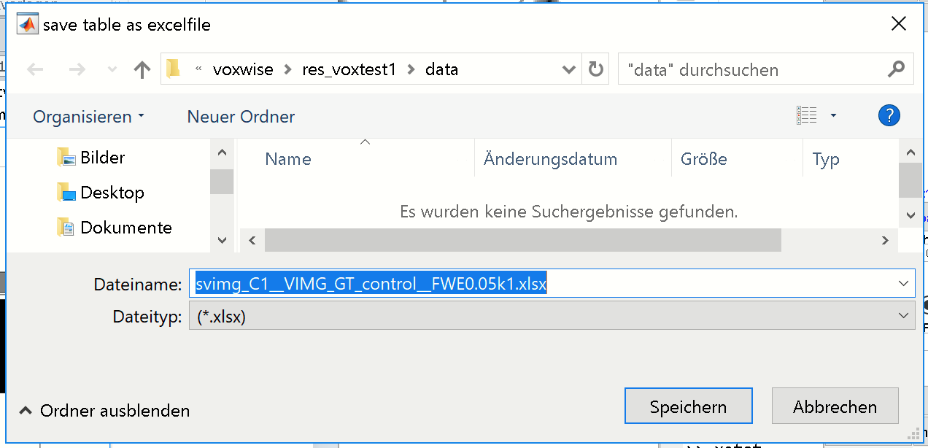

Without changing the path and filename, just hit the [save]-button.

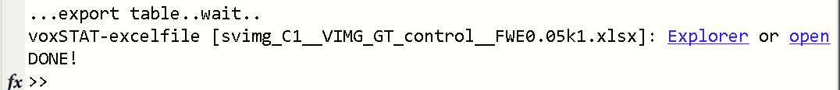

When done click the “open”-hyperlink to open the Excel file. The Excel file contains two sheets.

The “voxstat”-sheet contains the results-table:

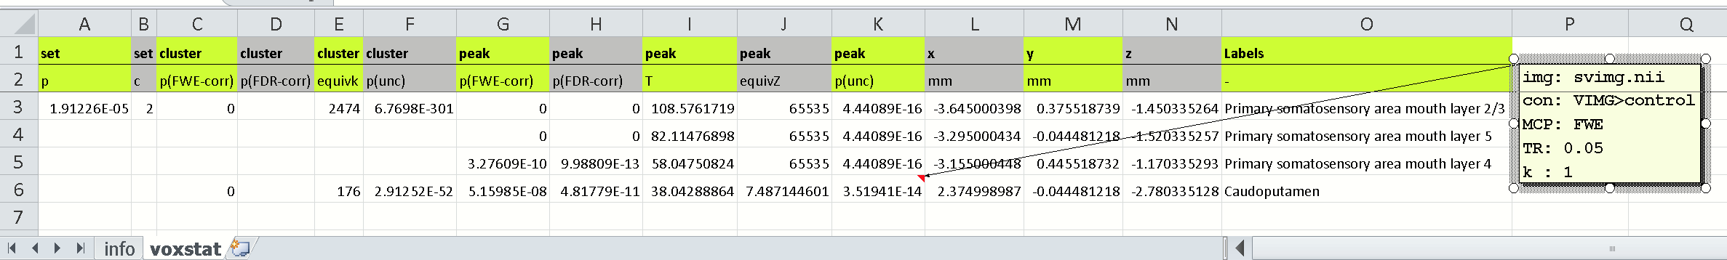

The “info”-sheet contains information to backtrack the statistical results:

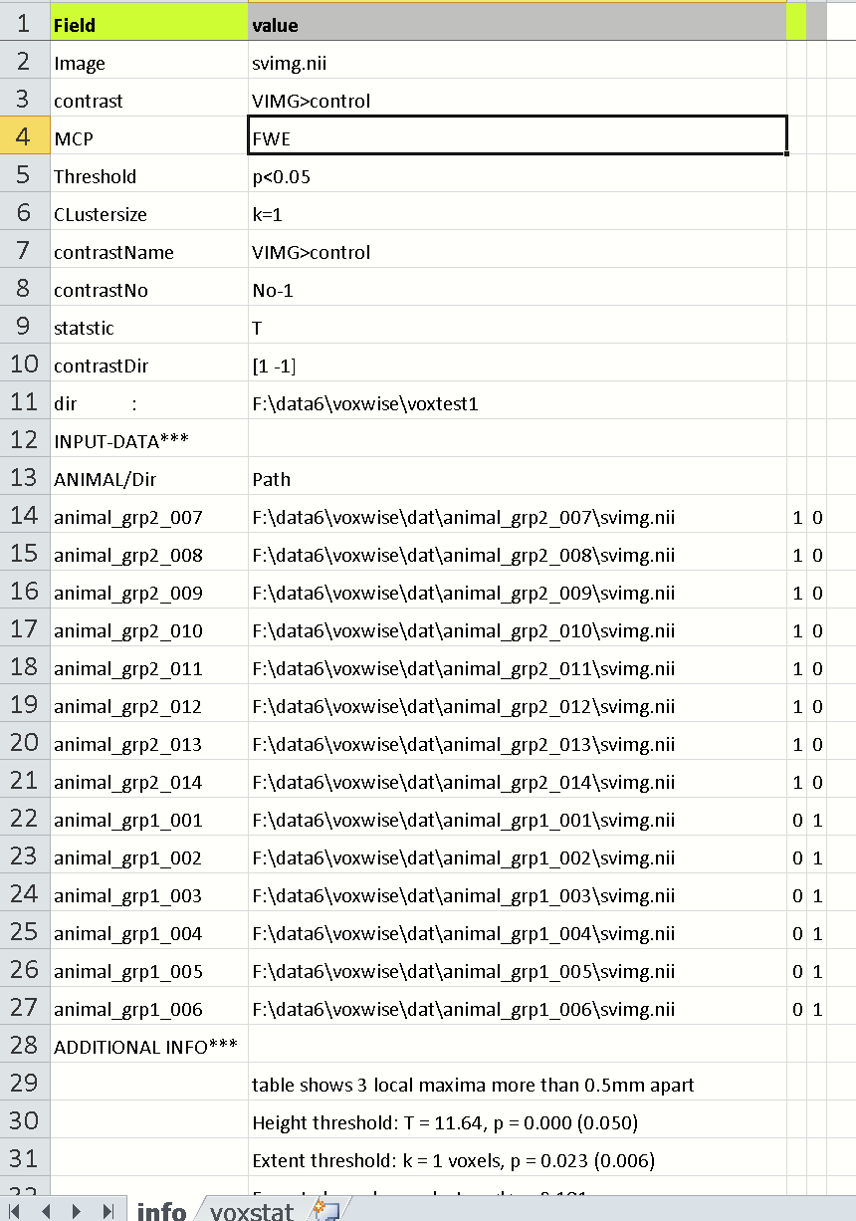

**3.2) DISPLAY RESULT TABLE IN COMMAND WINDOW**

Select [table-2-CMD]-button display the results-table in the command window:

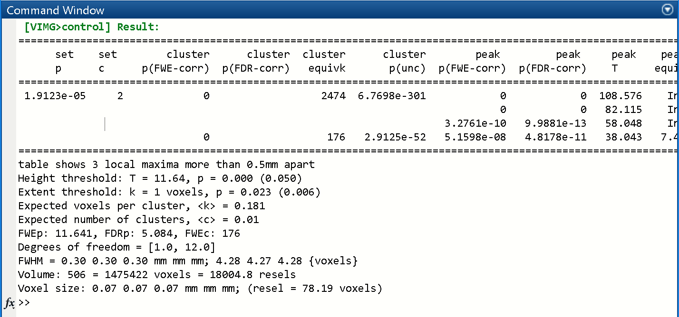

**3.3) EXPORT RESULTS-TABLE AS TXT-FILE**

To export the results as text-file, hit the [export txt]-button. When path/file is not changed this will save the results-table as “svimg_C1__VIMG_GT_control__FWE0.05k1.txt” in the “res_voxtest1\data”-folder:

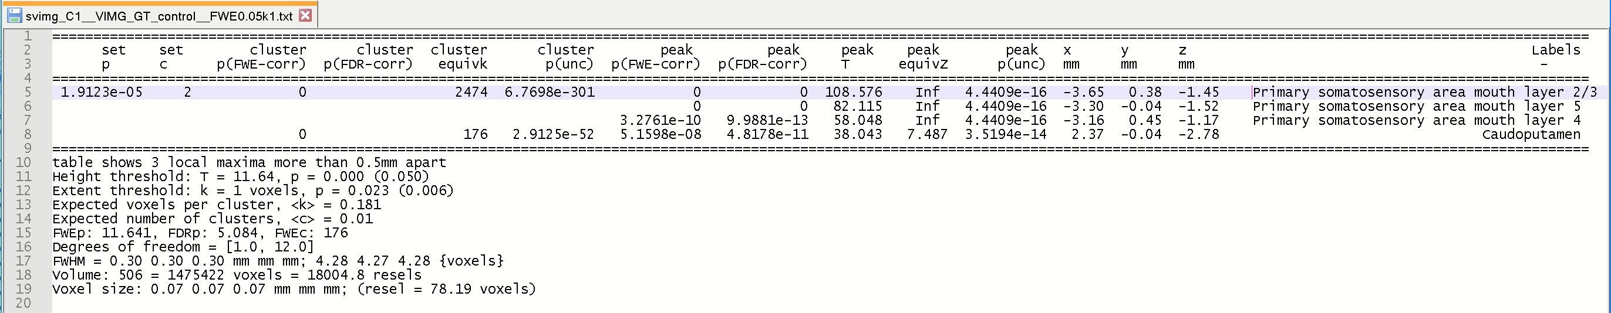

**3.4) SAVE THREHOLDED IMAGE AS NIFTI-FILE**

To save the thresholded (surviving) t-map as NIFTI-file hit the [save volume]-button. The GUI will prompt you for a path and a proper filename. Note that per default, the output-path is predefined (new folder: ‘res_’+analysis-folder), here: “res_voxtest1” in the subfolder “data”. Also, the filename is predefined, based on the image, contrast-number, contrast-name, method, p-value and clustersize. Thus, the filename is: “thresh_svimg_C1__VIMG_GT_control__FWE0.05k1.nii”.

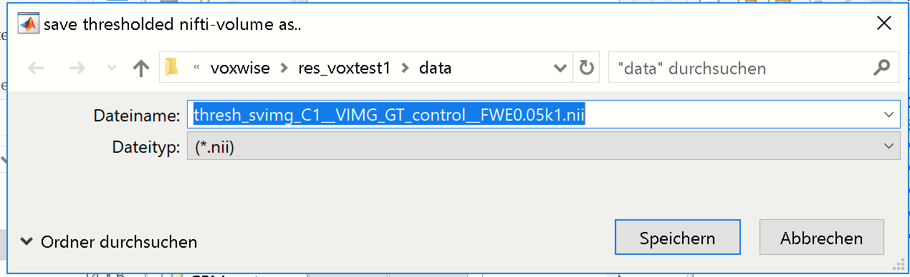

When done you can select the hyperlink ‘MRicron’ from the command-window to open the saved statistical t-map overlaid onto the template (‘AVGT.nii’) via MRicron.



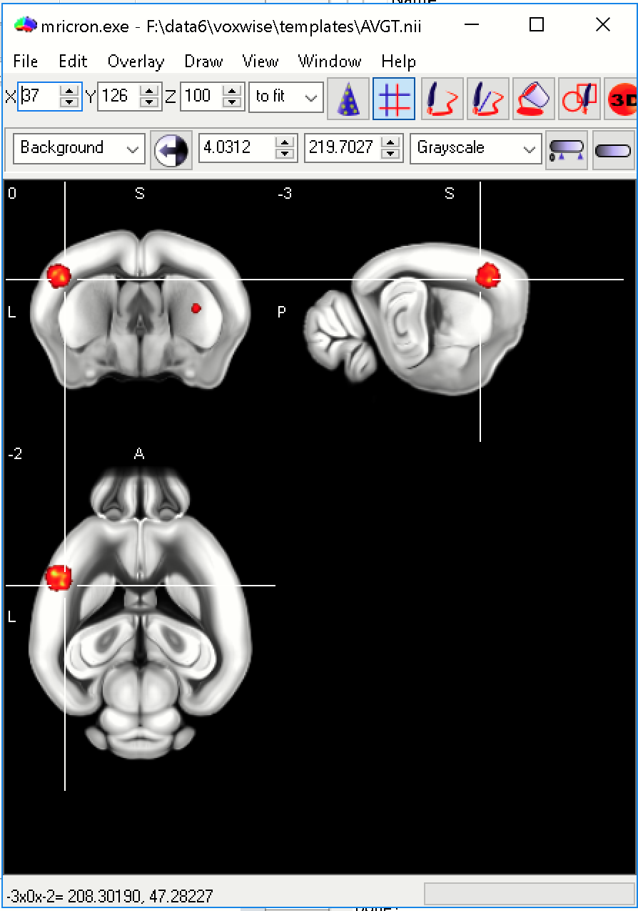

Alternatively, you can hit the [show MRicron]-button from the xstat-GUI and select the respective NIFTI (“thresh_svimg_C1__VIMG_GT_control__FWE0.05k1.nii”).

**3.5) EXTRACT PEAK DATA**

To extract the single data (for each animal) of the surviving peak-data of the results-table hit the [extract data] button. The GUI will prompt you for a path and a proper filename of the file. Note that per default, the output-path is predefined (new folder: ‘res_’+analysis-folder), here: “res_voxtest1” in the subfolder “data”. Also, the filename is predefined, based on the image, contrast-number, contrast-name, method, p-value and clustersize. Thus the filename is: “svimg_C1__VIMG_GT_control__FWE0.05k1_NPC3_**SINGLEDATA**.xlsx”. Thus, just hit [save].



When done, hit the “open”-hyperlink from the cmd-window to open the Excelfile:

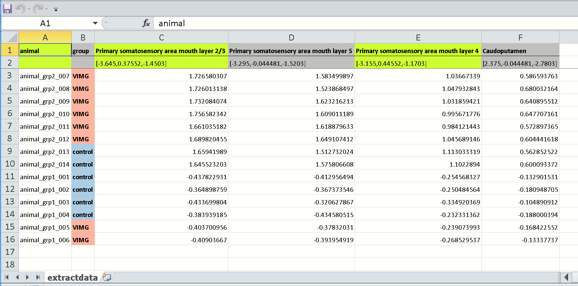

The file contains the single-values from each animal (with animal-id and group-assignment) for the 4 observed peaks.

**3.6) CREATE SUMMARY OF CURRENT CONTRAST**

To obtain a fast summary of the current contrast, select from the **xstat-MENU**: **posthoc/create summary of current contrast**. This will create a Powerpoint-file with the summay for the 1st contrast. Note that the current settings from the xstat-GUI (MCP, thresh, CL-l, “#p/Cl”and “CLdist”) are used.



When done, hit the “open”-hyperlink from the cmd-window to open the PPT-file:

Note that the PPT-file is directly stored in the “res_voxtest1”-folder (‘res_’+analysis-folder).

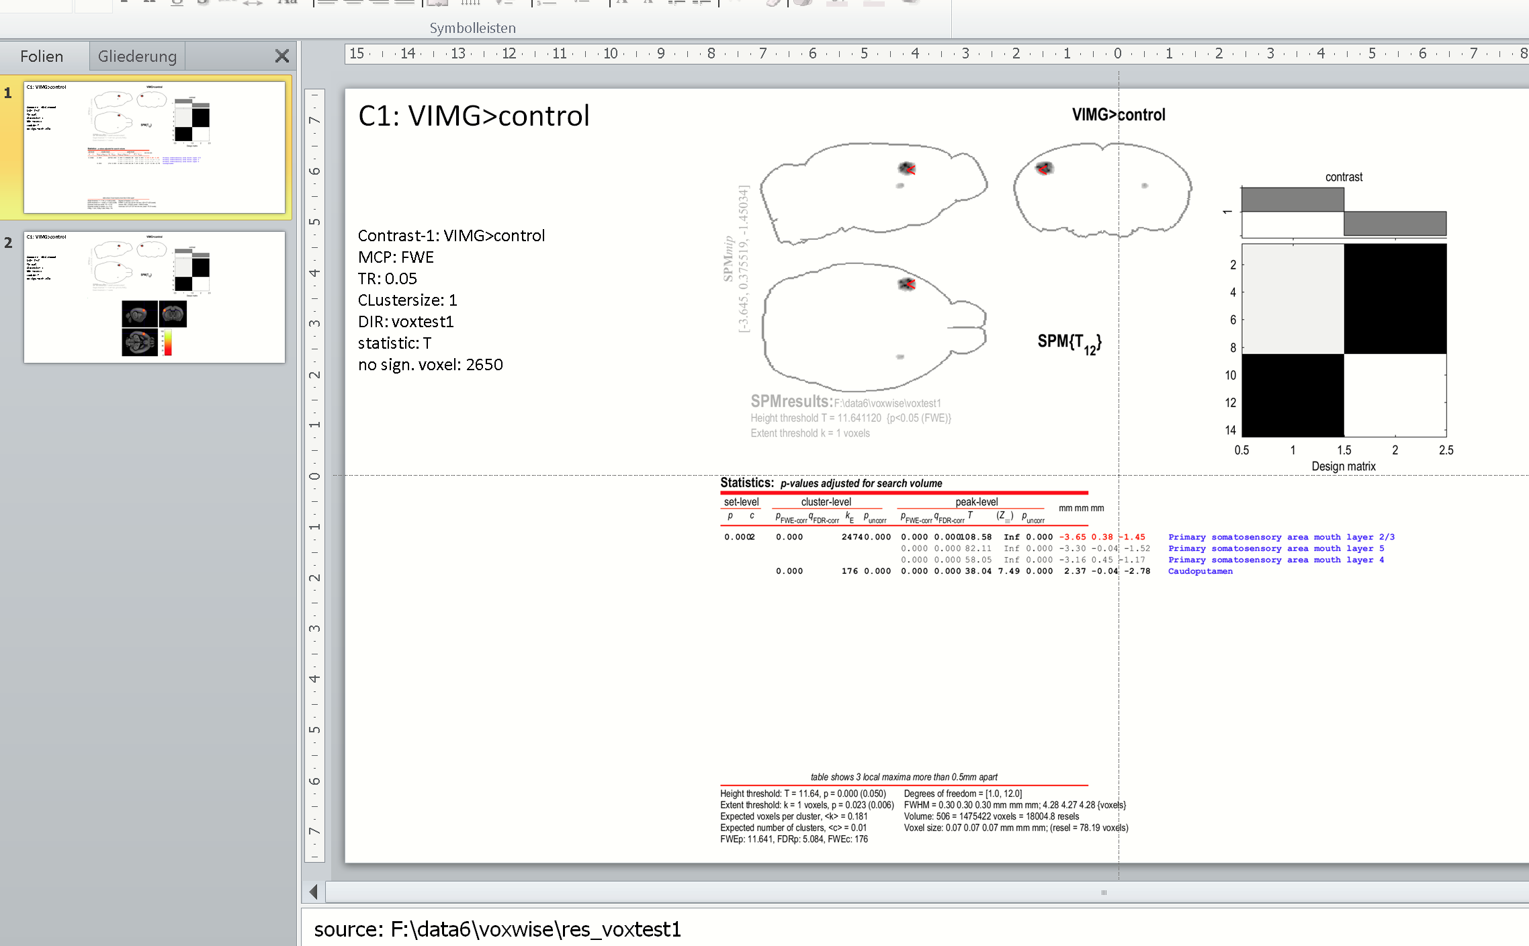

**3.7) Change to Cluster-based approach**

Now, we are switching from the FEW-method to the cluster-based approach. For this select **'clusterbased, at 0.001'** from the pull-down menu left to MCP-field:

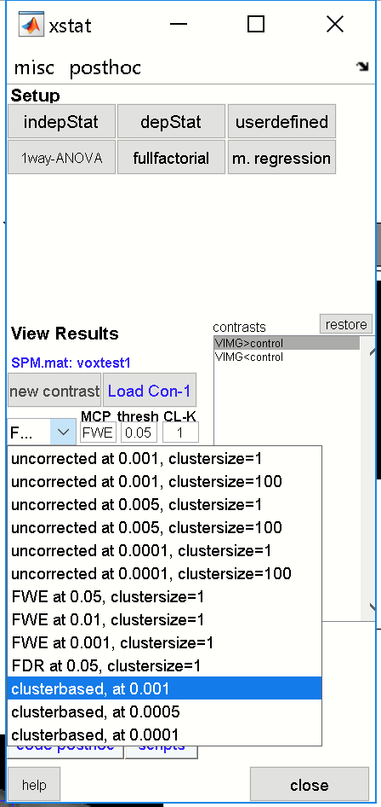

When selected the cluster-based approach will automatically run, and first set the p-value to 0.001, uncorrected and estimates the spatial threshold, i.e. the minimum number of neighboring voxels mandatory for a significant cluster. Next, this spatial threshold is used for the cluster-based approach. Here, a significant cluster-based height threshold at p=0.001 needs 164 neighboring voxels to survive.

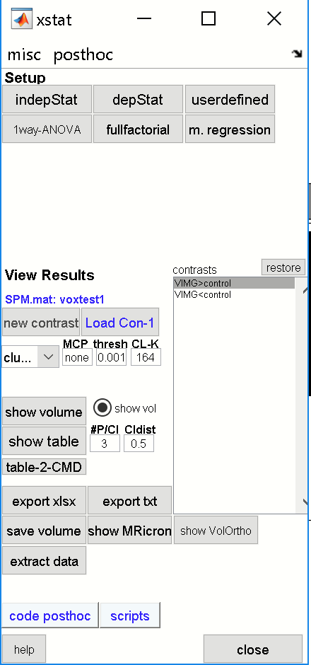 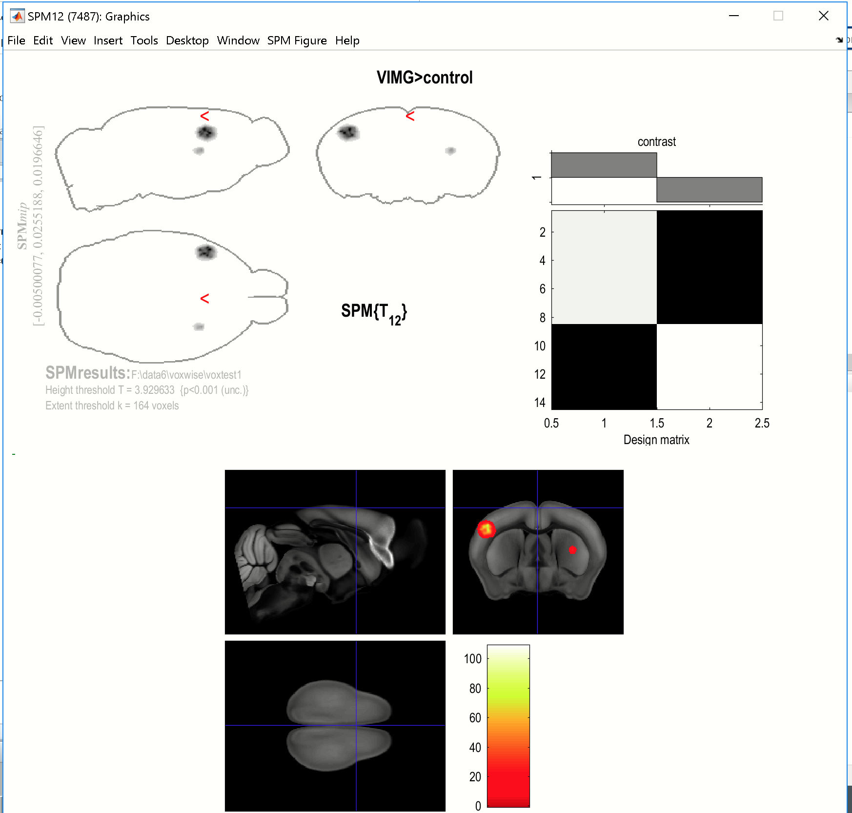

For the cluster-based approach, the results are quite similar compared to the FWE-approach.

**4) Check the other contrast**

Now, select the 2nd contrast **'VIMG<control'** form the xstat-contrast listbox.

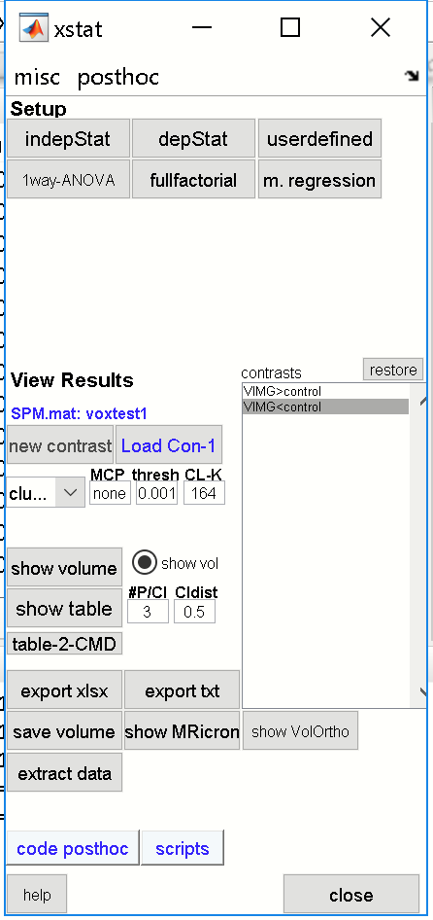

Based on the previous settings, **the cluster-based approach** shows no significant clusters.

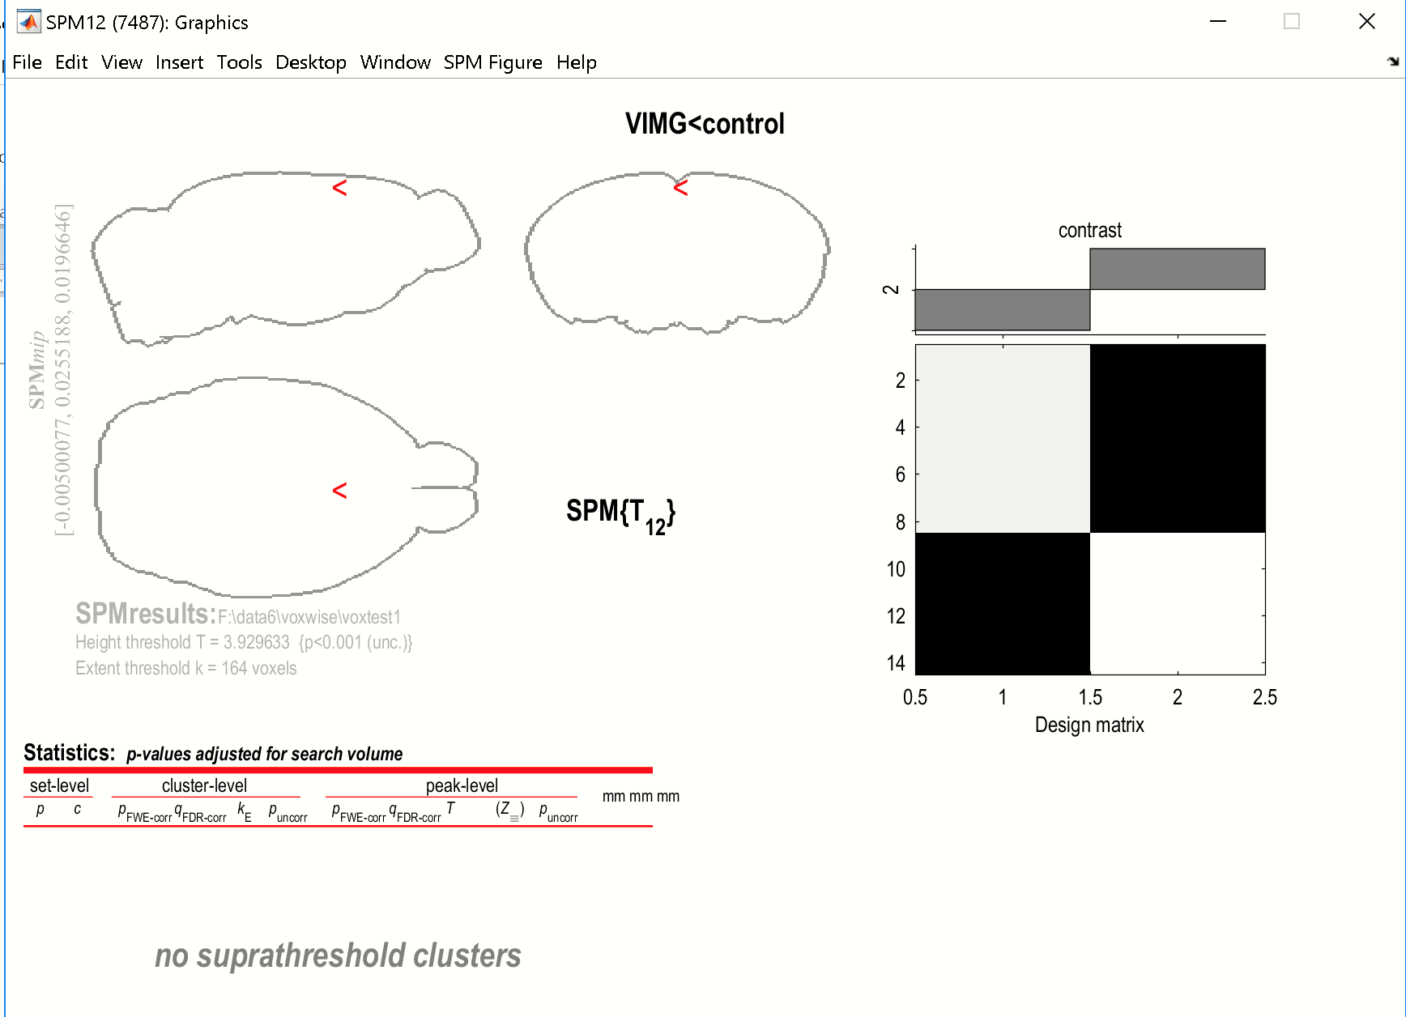

Now, select **'FWE at 0.05, clustersize=1'** from the xstat-pulldown MENU and **update** the graphics-window by selecting the 2nd contrast **'VIMG<control'** from the contrast-listbox

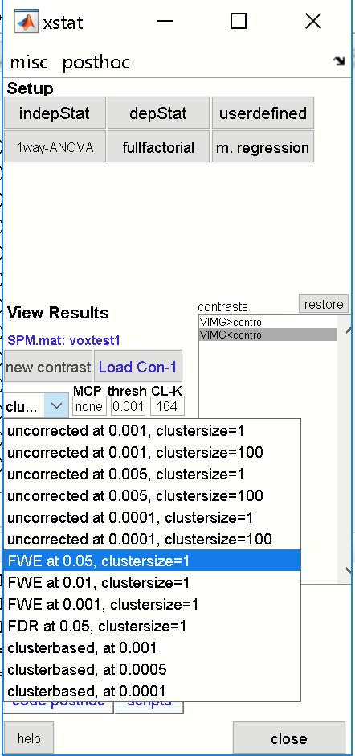

We see that for the 2nd contrast, **'VIMG<control',** nothingsurvivesFWE-correction:

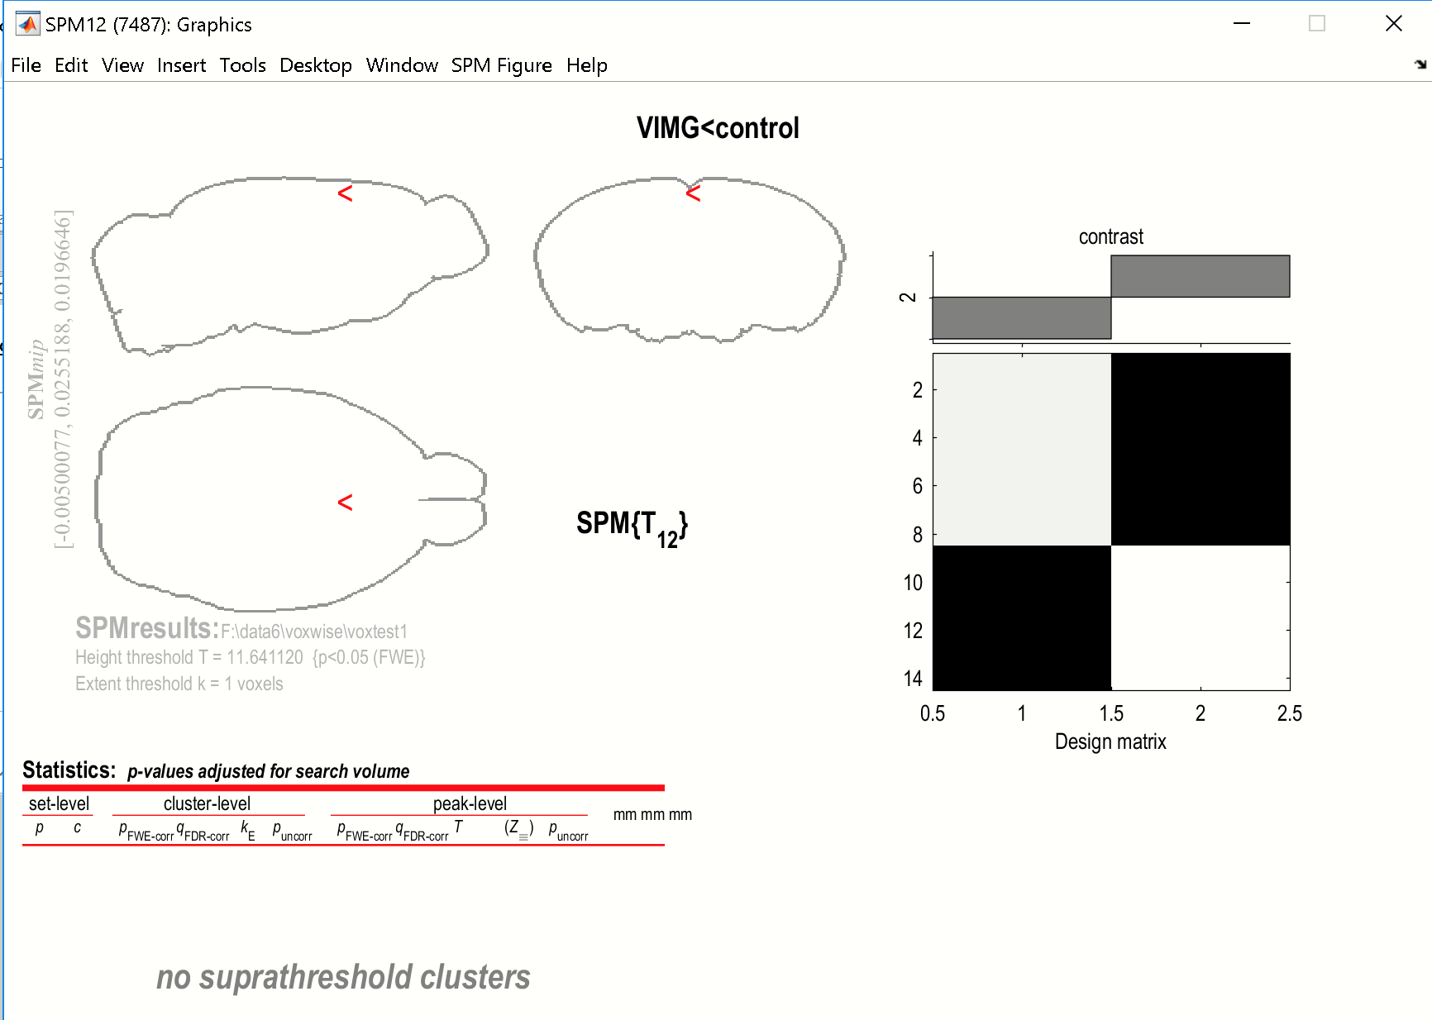

**5) CREATE BIG-SUMMARY**

Sometimes it is useful to obtain a summary for all existing contrasts and all methods (uncorrected, FEW and cluster-based approach). For this, select from the xstat-MENU: **posthoc/all methods summary & export tables all contrasts**.This will create three PowerPoint-files in the “**res_voxtest1**”-folder and also export the resulting tables as Excel-files and will store the respective t-maps as NIFTI-files.

**The procedure will create three PPT-files:**

‘sum_UNCOR_svimg_none0.001k1.pptx’ -uncorrected at p=0.001

‘sum_FWE_svimg_FWE0.05k1.pptx’ -using the FWE approach

‘sum_CLUST_svimg_CLUST0.001k164.pptx’ -using the cluster-based approach

The below figure displays the summary of the FWE approach. This Powerpoint-file contains the table (or first part of the table, depending on the table size) and displays the volume with surviving voxels for the 1st contrast (slides 1-2) and the 2nd contrast (slides 3-4). Note, there are no surviving voxels for the 2nd contrast.

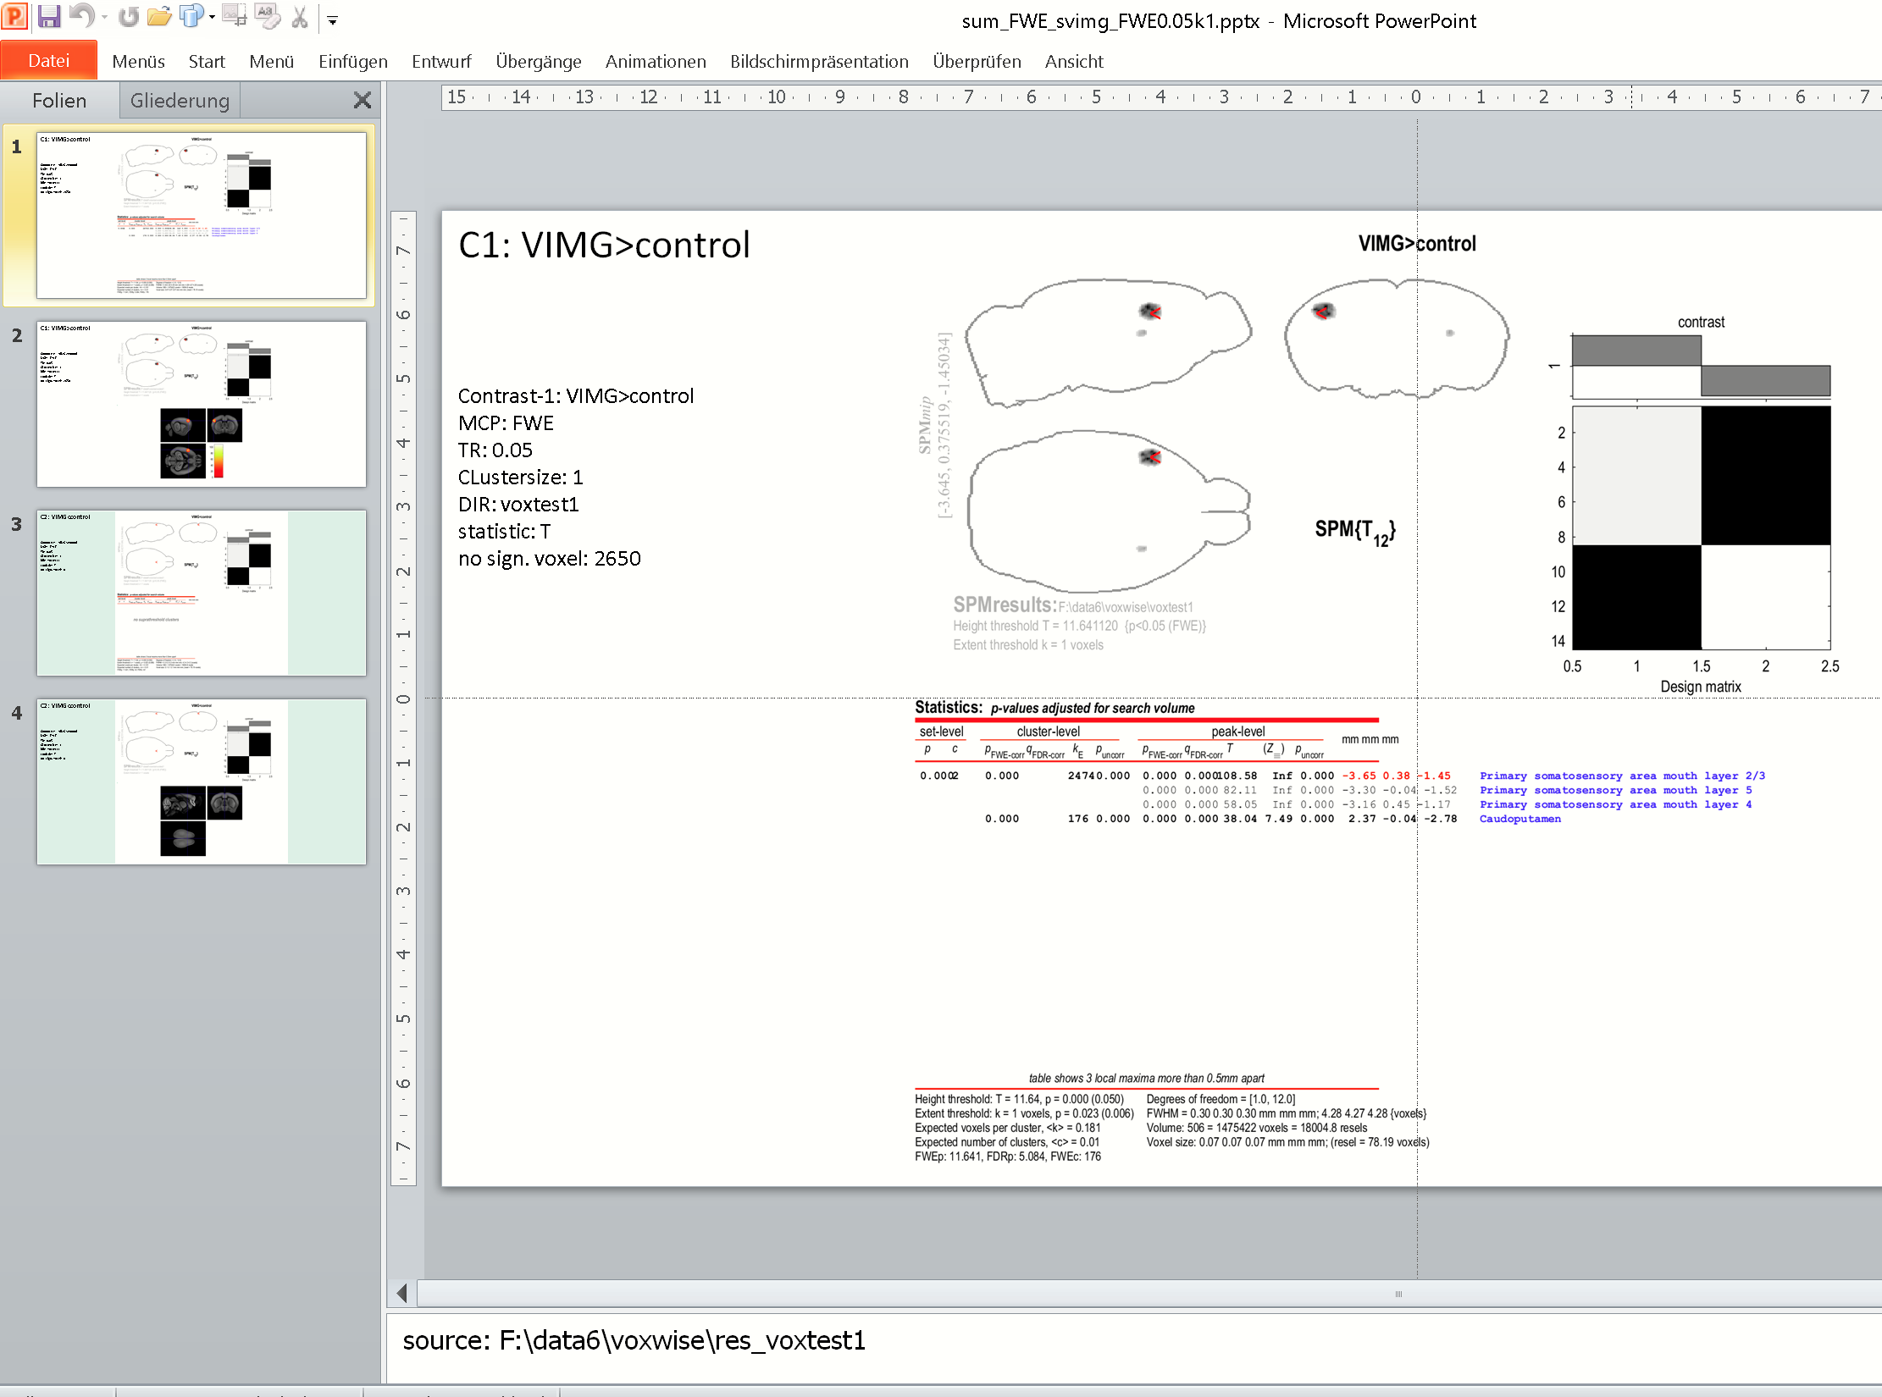

Note that this routine also creates the NIFTI-files and result-tables (Excel-files) for all contrast. The folder **“..\res_voxtest1\data“** contains these files:

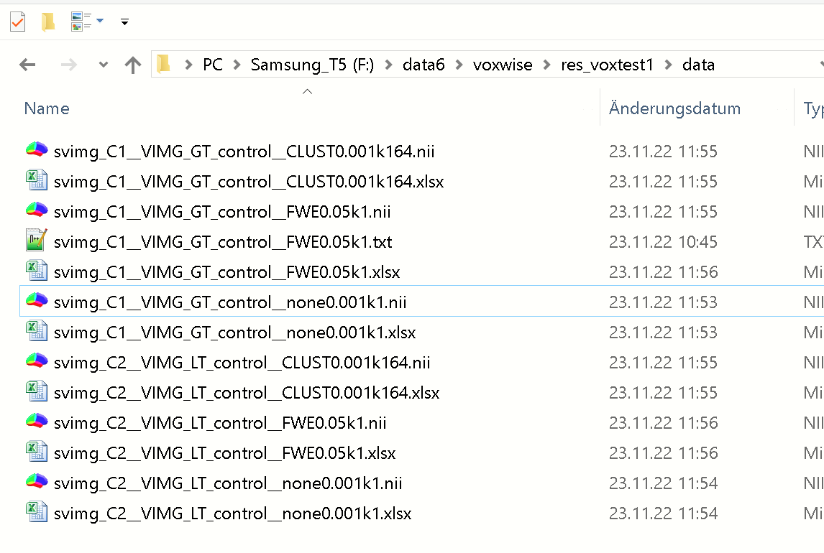

**6) Define new Contrast**

To define a new contrast hit [new contrast]-button from the **xstat-GUI**. When asked, select the specific SPM.mat from the voxelwise analysis-folder. In the SPM contrast-manager, select [Define new contrast]:

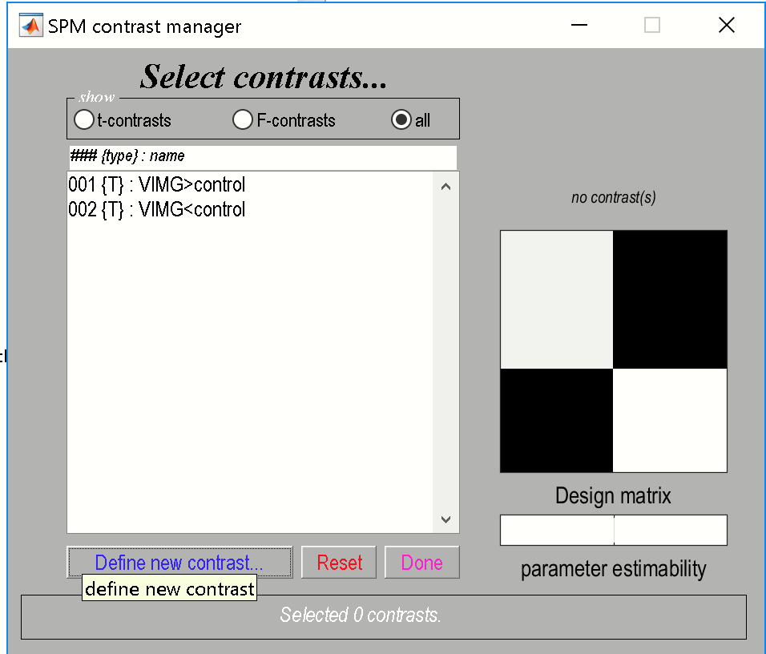

Here we select an F-contrast (radio: F-contrast). Enter ‘F-stat’ in the name-field and enter [1 -1] in the field ‘contrast weights matrix’. Please try to avoid special characters for the contrast-name.

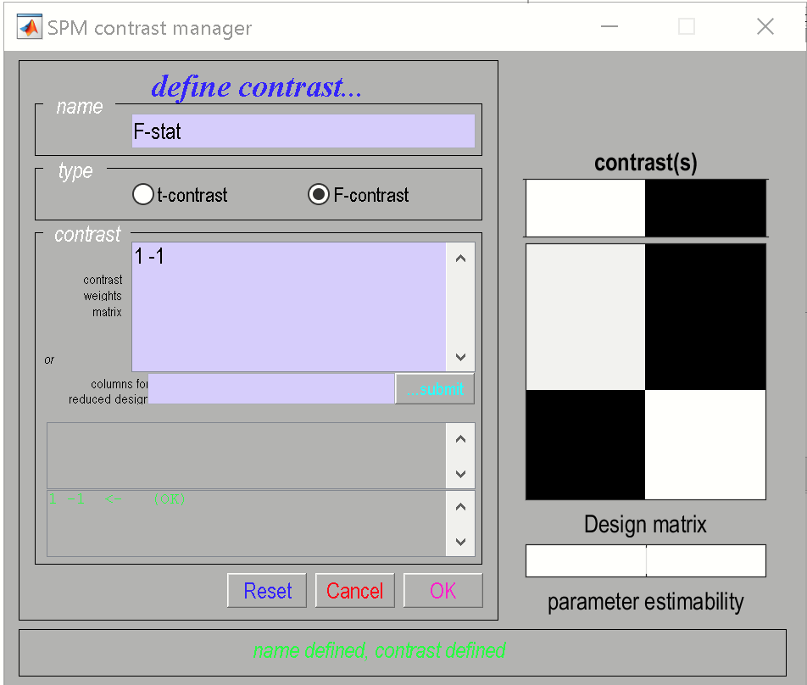

Then, hit [submit]-button, and hit [**OK**]. When done, a 3rd contrast (F-contrast) with name **“F-stat”** is created.

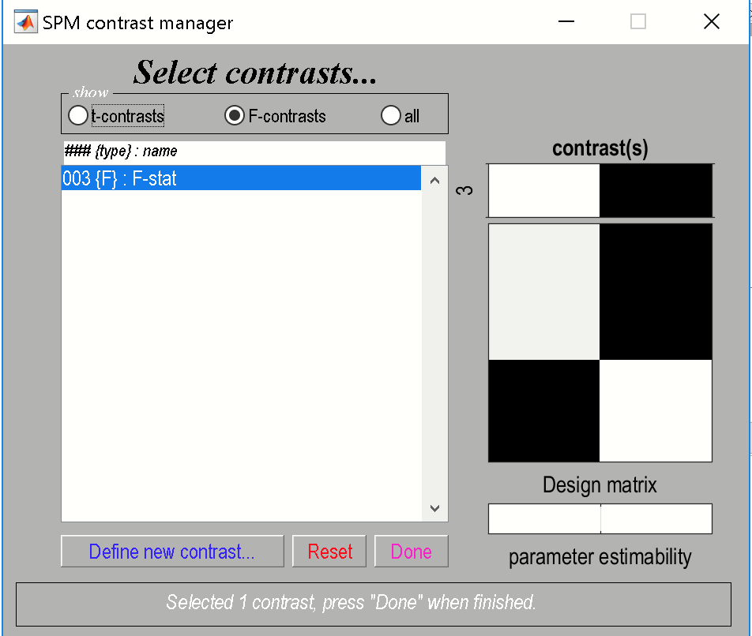

Hit [Done]-button. Next, you have to enter some parameters:

1) Masking, click [none].

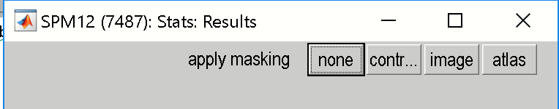

2) Method to control the multiple comparison problem: hit [FWE].

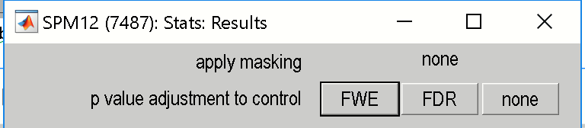

3) p-value: (keep 0.05), just hit the [enter]-key.

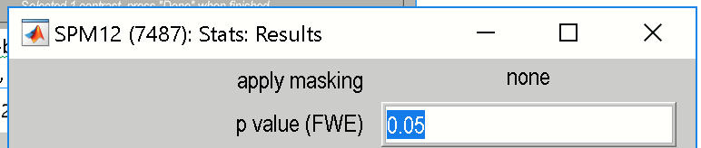

4) Extend/spatial threshold: (keep 0), just hit the [enter]-key.

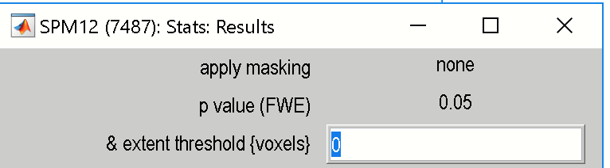

This will produce the output in the graphic window for the F-contrast:

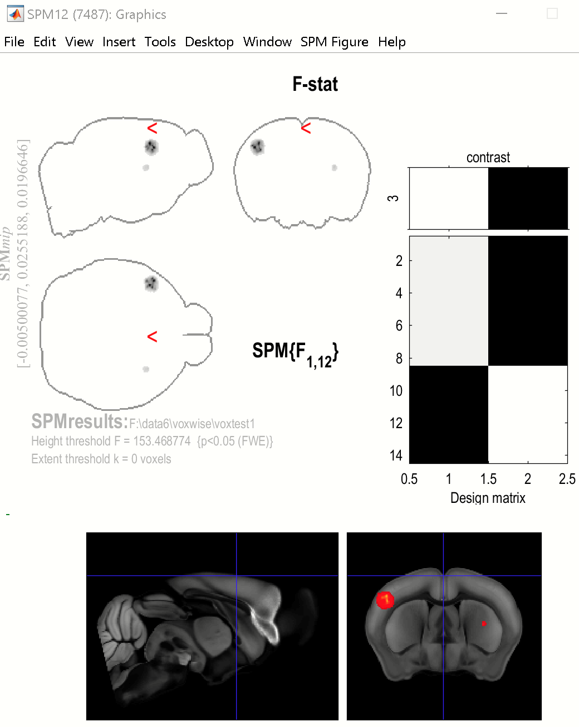

Note also that the contrast list box in the xstat-GUI will be updated (now containing 3 contrasts):

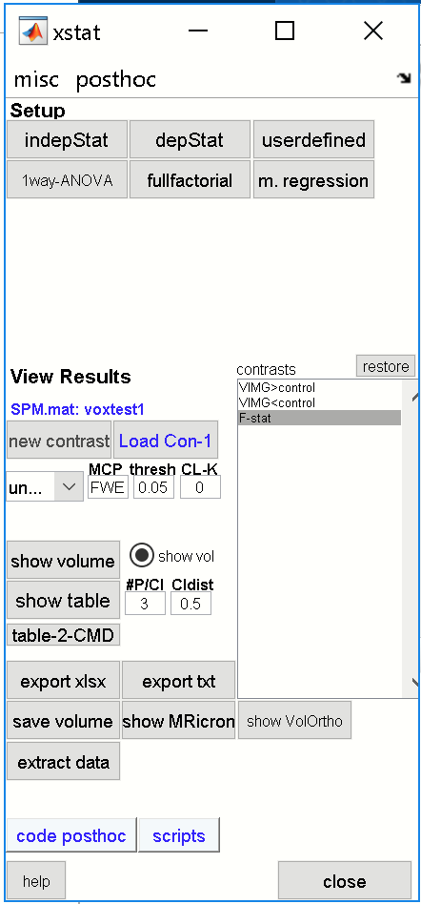

From here you can modify the parameters and **update** the graphic window by selecting a contrast (such as the 3rd contrast) from the contrast-listbox.

**7) Work from Command line**

**7.1) run voxelwise statistic from command line**

z=[];

z.stattype = 'twosamplettest'; %STATISTICAL TEST

z.excelfile = 'F:\data6\voxwise\group\groupassignment.xlsx'; %[Excelfile] containing mouseIDs and group

z.sheetnumber = [1]; %sheet with columns mouseIDs and group

z.mouseID_col = [1]; %column index with the MouseIDs

z.group_col = [2]; %column index with group assignment

z.data_dir = 'F:\data6\voxwise\dat'; %data directory (upper directory)

z.inputimage = 'vimg.nii'; %image name (nifti) to run the statistic

z.AVGT = 'F:\data6\voxwise\templates\AVGT.nii'; % TEMPLATE-file (in templates-folder)

z.ANO = 'F:\data6\voxwise\templates\ANO.nii'; % ATLAS-file (in templates-folder)

z.grp_comparison = '1vs2'; %groups to compare (do not modify)

z.mask = 'F:\data6\voxwise\templates\AVGTmask.nii'; %<optional> ”brainmask

z.smoothing = [1]; %<optional>smooth data: [0]no,[1]yes

z.smoothing_fwhm = [0.28 0.28 0.28]; %smoothing kernel (FWHM)

z.output_dir = 'voxtest2'; %path for output-folder for statistic

z.showSPMbatch = [0]; %hide|show pipeline in SPM-batch-manager

xstat(1,z); %RUN

execute this code to re-run the voxelwise statistic.

**7.2) Create full report**

xstat('loadspm','F:\data6\voxwise\voxtest2'): % open xstat-GUI and load SPM.mat-file

xstat('fullreport'); % create full report, i.e. three PPTfiles (uncorrected, FWE, cluster-based) + export result tables and statistical maps as NIFTI-files

For more information, see scripts [scripts]-button and help of xstat.